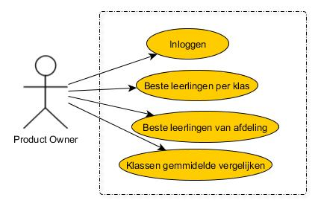 Use Case diagram

Use Case templates

|  |  |
| --- | --- |
| Use Case naam | Inloggen |
| Versie | 1.0.0 |
| Actor | Product owner |
| Pre-conditie |  |
| Beschrijving |  |
| Uitzonderingen |  |
| Non-functionele eisen |  |
| Post-conditie |  |